

Group Number: 6

LEAD
Software Requirements Specification (SRS)
Version: 1.0
LEAD_SE06_v1.0

Revision History

Sl. No. | Prepared/  Modified by | E-mail | Version | Date | Approved by | Descriptions/  Remarks
1. | 1-Maryam Muhammad  2-Mennah Rabie  3-Tasneem Saif  4- Yasmeen Hesham | 1-maryam.m.abdelmoneam@gmail.com  2-  eng.m.rabie7@hotmail.com  3-  tsasaif@hotmail.com  4-  Yasmeenhesham09@gmail.com | 1.0 | 3/31/2016

Distribution list
Name | E-mail
Dr.Bassem Ibrahim | basem@eng.cu.edu.eg
Eng.Lydia Waheed | eng.lydiawahid@hotmail.com
May Mohamed | mai_awadalla@yahoo.com | IEEE member
Mennah Lotfy | mennalotfy33@gmail.com | STP member
Rania Alaa | Rania.alaaa@yahoo.com | Meshwar member

Table of Contents
Contents
1. Introduction 5
1.1 Purpose of this Document 5
1.2 Scope 5
1.3 Table of Acronyms and Definitions 5
1.4 References 5
1.5 Overview of Document 5
2. System Architecture 6
3. Design Models 6
3.1 Design Patterns Description 6
3.1.1Singleton 6
3.1.2MVC 6
3.2 Class Diagrams 7
3.3 Interaction Diagrams 7
4. Data Models 10
5. System Deployment 10
6. Traceability to Requirements 10

List of Tables
Table1: Traceability Matrix 10

List of Figures

Figure1: System Architecture 6
Figure2: Class Diagrams 7
Figure3: SD-01 7
Figure4: SD-02 8
Figure5: SD-03 8
Figure6: SD-08 9
Figure7: SD-09 9
Figure8: ER Diagram 10
Figure9: System Deployment 10

Introduction

Purpose of this Document

The purpose of this document is to help the user know how the system will be designed starting with classes then the interaction between classes, it’ll also help the user know how the database is designed, the document also contains table of definitions for every abbreviation used in the document.

Scope

At this iteration the project is mainly concerned with building a centralized database system, and building modules that allows many features which are:

1-Every user can sign up in our website by her/his first name, last name, email, and password.
2- Every user can login to our website by her/his email, and password.
3-User can surf our website to know any information they want to know about these three student Activities (STP, Meshwar,
and IEEE). And this feature is allowed for any user even if he/she doesn't have an account on our website.
4-Every user who has registered in our website has her/his own profile that contains her/his information and the categories
(Robotics, Web development... etc.) of workshops, or events.
5-The admin has a permission to write, or update a post.
6-User can search about student activities. And this feature is allowed for any user even if he/she doesn’t have an account
on our website.

Table of Acronyms and Definitions

Term | Definitions, Acronyms, and Abbreviations
LEAD | It is the website name and every letter has its meaning which are "Learn", "Explore", "Achieve", and "Develop".
Database | Collection of all the information monitored by this system.
SD | Sequence Diagram
UC | Use Case
SDS | Is a written description of a software product, that a software designer writes in order to give a software development team overall guidance to the architecture of the software project. An SDS usually accompanies an architecture diagram with pointers to detailed feature specifications of smaller pieces of the design.
SRS | A document that completely describes all of the functions of a proposed system and the constraints under which it must operate.
MVC | Model - View – Controller (Design Pattern)

References

1.4.1 SRS submitted before by our team.

Overview of Document

The rest of this document describes our system architectural design. It represents the subsystems, dependencies, and the interaction between them. It contains the description of the used design patterns.
It contains different design models that model our system which are Class, Activity, and Interaction diagrams. It also contains the ERD to model the relationships for the database maintained by our system.

It shows the component and the deployment diagrams to model how the system will be deployed. It also shows a matrix similar to the traceability matrix in the SRS document in order to map the requirements to design elements.

System Architecture

The architecture of our system follows the MVC design pattern:
- The interface which is the client side part (view)
- The controller which connects between the client side and the database side
- The model which communicates with the database

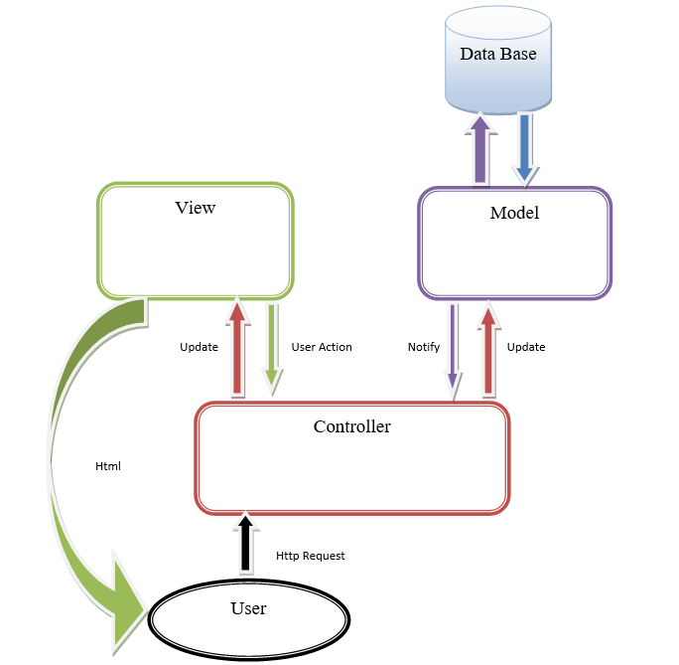

Figure1

Design Models

Design Patterns Description

Singleton
First design pattern used is Singleton, it is used to make database connection as we need only one instance of it, and it’s made in class DATABASE.

MVC
Second design pattern used is MVC it’s the base of our project, it’s used as it organizes the project into definite class and subclasses and makes it easier to understand.

Class Diagrams
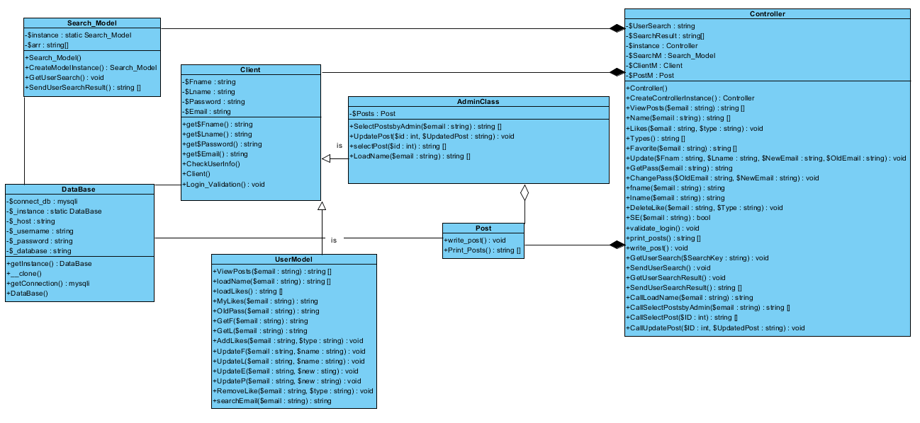
Figure2

Interaction Diagrams

SD-01
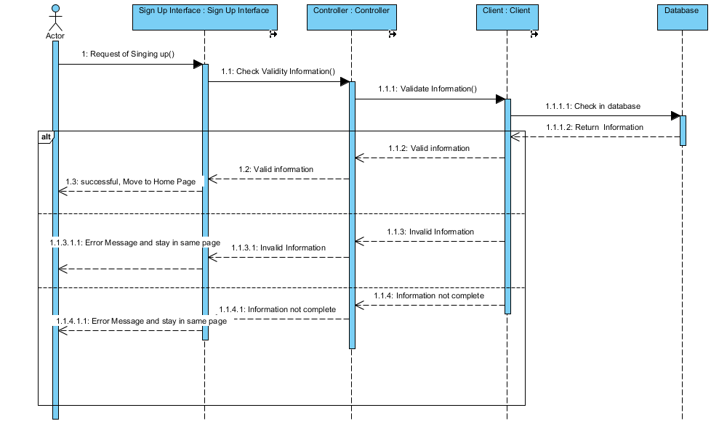

Figure3

SD-02
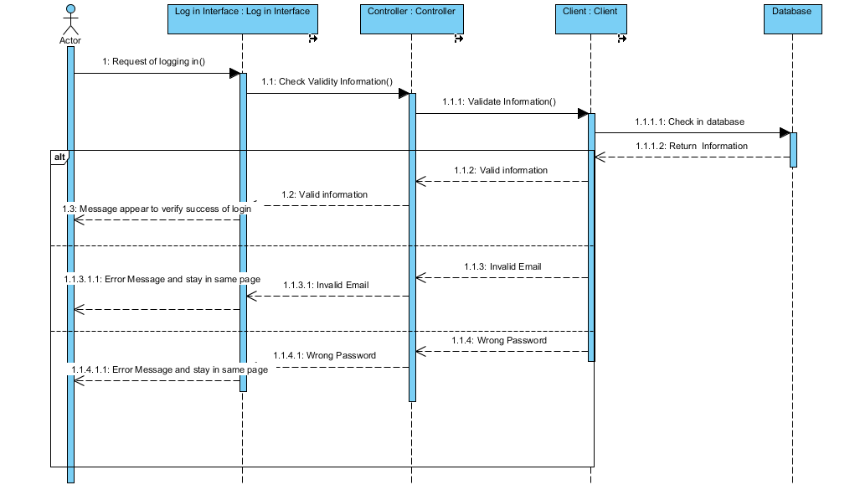
Figure4
SD-03
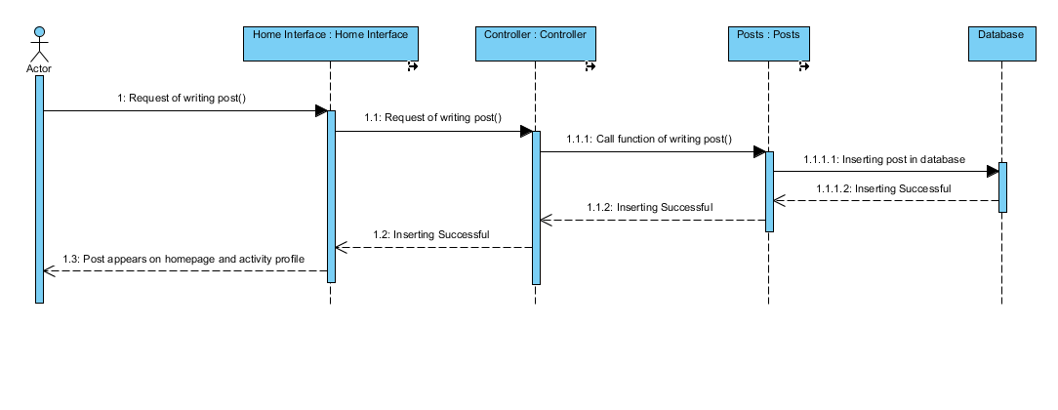
Figure5
SD-08
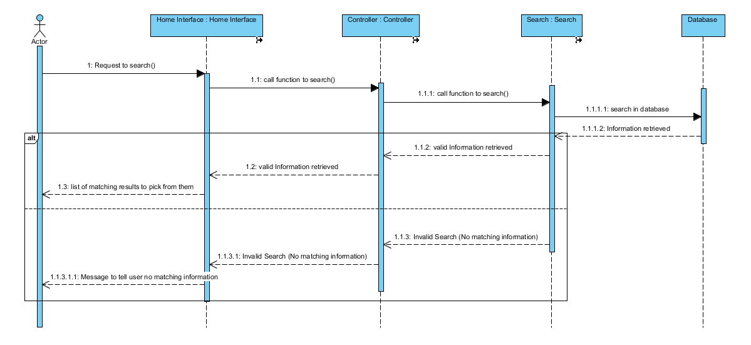
Figure6
SD-09
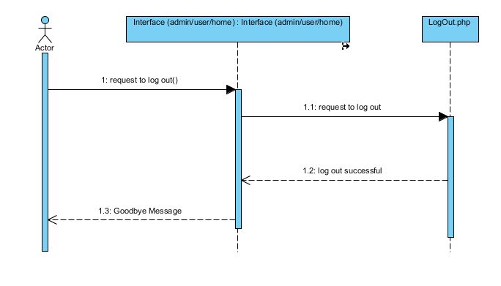
Figure7

Data Models
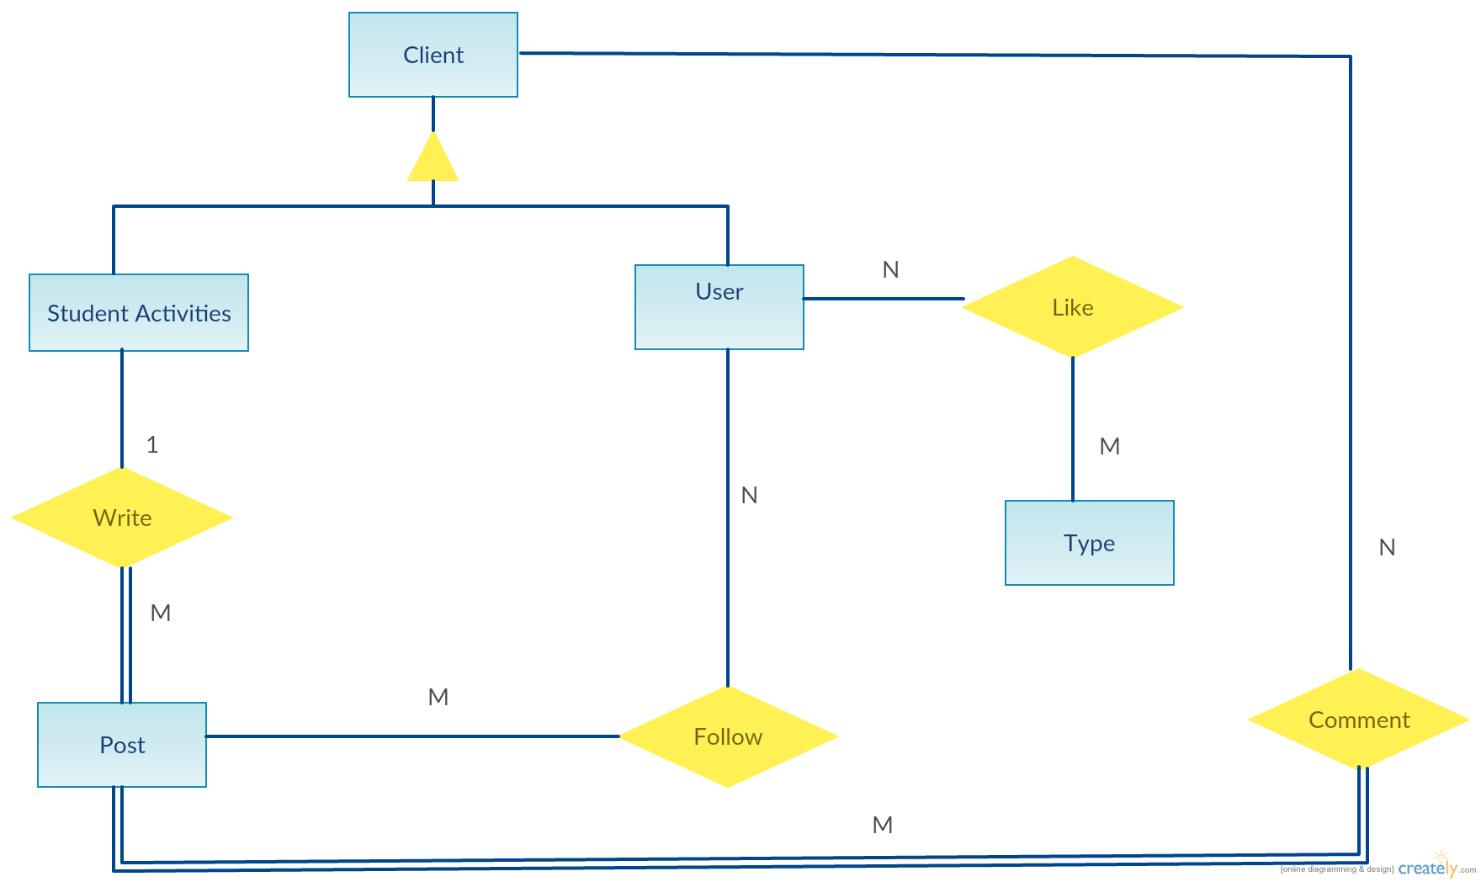
Figure8

System Deployment

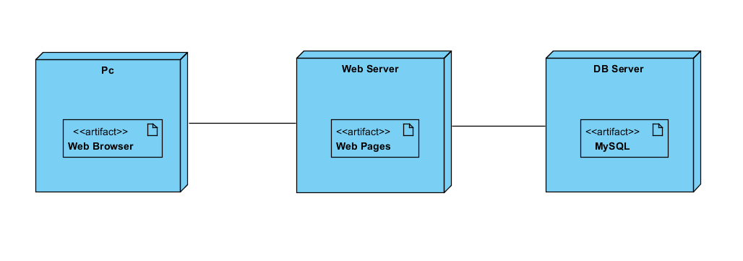
Figure9

Traceability to Requirements
 | SD-01 | SD-02 | SD-03 | SD-08 | SD-09
UC-01 | ✓
UC-02 |  | ✓
UC-03 |  |  | ✓
UC-08 |  |  |  | ✓
UC-09 |  |  |  |  | ✓

